Basic Pratice of Programming Jobsheet 2



From:
AL AZHAR RIZQI RIFA’I FIRDAUS
Class:
1 I
Absence:
01
Major:
Information Technology
Study Program:
Informatic Engineering
Experiment 1: Complete Case Study On Sequence
Question !
1. Mention sequentially what you do after college like experiment 1 question-1!
2. Rewrite and complete the algorithm in Experiment 1 No. 2!
3. Calculate mathematically the results of experiment 1 problem 3! What is the result?
4. If there is additional information as follows "Mr. Ahmad wants to plant a circular rose in the middle of his land. Pak Ahmad wants to maximize his land so that as much as possible there are only a few vacant lands. What is the area of Mr. Ahmad's land planted with Mawar flowers? " Rewrite the steps for making the correct algorithm!
5. After additional data about question 4, what is the area of Mr. Ahmad's land that is not planted with roses?
Answer
- What I do after college.
- After leave the class, I will go down the building using elevator.
- Then go to parking lot to pickup the motorcycle.
- If it rain, I will use the raincoat while driving. And then if it bright, I will driving without using raincoat.
- After arrived at home I clean my body.
- Algorithm :
- From the start the frog jumps in the 0 direction.
- Then jump again in the 0 direction.
- Then the frog turns to the lily pad in the 6 direction.
- Then the frog jumps down to the lily pad in the 6 direction.
- Then the frog jumps again in the 6 direction.
- Then the frog jumps to the lily pad in the 4 direction.
- Then jump again in the 4 direction.
- Then the frog jumps to the lily pad in the 2 direction.
- Then jump again in the 2 direction.
- Then the frog jumps to the lily pad in the 4 direction.
- Then jump again in the 4 direction.
- Then the frog jumps to the lily pad in the 1 direction and finish.
- Calculate:
- Periphery land = 64 m
- Side 64 / 4 = 16m
- Land area = 16 * 16 = 256m ** 2.
- Input : Side area of Mr Ahmad's land.
Process :
- Find out known data.
- Side square 16m and radius circle 8m.
- Search for land area circle.
- Land area circle 3,14 * 8 * 8 = 200,96m**2.
Output : Land area of Mr. Ahmad's land planted with rose flowers.
- Input : Side area of Mr Ahmad's land.
Process :
- Find out known data.
- Side square 16m and radius circle 8m.
- Search for land area square and circle.
- Land area square 16 * 16 = 256m**2 and the circle 3,14 * 8 * 8 = 200,96m**2.
- Land area square and circle be subtracted.
- The result is 256 – 200,96 = 55,04 m**2.
Output : Land area of Mr. Ahmad's land not planted with rose flowers.

Experiment 2: Complete a Case Study About Selection
Question !
1. Rewrite and complete the algorithm in experiment 2!
2. Write the algorithm of the regulation SP1, SP2, and SP3 at JTI Polinema as you know!
Answer
- Input : River, River connectivity information
Process :
- Beaver is in the middle of several river meetings. He can swim from the river B / D / E / F / G.
- If starting from B then the track that can be traversed by choosing river A or C.
- If it crosses river A, then:
  - River A continues to river D.
  - From D has the option to E / F / G river. If you choose F or G then it is possibility that one river must be crossed more than once. Then the river E was chosen.
  - From E, proceed to the connected and have same direction river, river H.
  - From the river H continued to the river that is connected and have same direction, there are F-G-C.
  - So the path Beaver goes through is B-C-G-F-H-E-D-A (output).
- If it starts from D then the track that can be traversed is river A.
Then the track that can be traversed by choosing river B or C.
If it crosses river C, then:
  - River C continues to river G.
  - From G has continued to middle of several river.
  - From middle of several river has the option to F or E river. Then the river F was chosen.
  - From F, proceed to the connected and have same direction river, river H.
  - From the river H continued to the river that is connected and have same direction, there are E-B.
  - So the path Beaver goes through is D-A-C-G-F-H-E-B (output).
- If starting from E then the track that can be traversed is river H then continued to river F.
From F has continued to middle of several river.
Then the track that can be traversed by choosing river D / B / G.
If it crosses river G, then:
  - River G continues to river C.
  - From C has the option to A or B river. Then the river A was chosen.
  - From A, continues to river D.
  - From D has continued to middle of several river.
  - And then the last river is B.
  - So the path Beaver goes through is E-H-F-G-C-A-D-B (output).
- If starting from F then the track that can be traversed is river H then continued to river E.
From E has continued to middle of several river.
Then the track that can be traversed by choosing river D / B / G.
If it crosses river G, then:
  - River G continues to river C.
  - From C has the option to A or B river. Then the river A was chosen.
  - From A, continues to river D.
  - From D has continued to middle of several river.
  - And then the last river is B.
  - So the path Beaver goes through is F-H-E-G-C-A-D-B (output
- If starting from G then the track that can be traversed is river C.
Then the track that can be traversed by choosing river A or B.
If it crosses river A, then:
  - River A continues to river D.
  - From D has continued to middle of several river.
  - From middle of several river has the option to B / F / E river. If you choose B then it is possibility that one river must be crossed more than once. Then the river E was chosen.
  - From E, proceed to the connected and have same direction river, river H.
  - From the river H continued to the river that is connected and have same direction, there are F-B.
  - So the path Beaver goes through is G-C-A-D-E-H-F-B(output).
Output : Path of the entire river
- Input : Regulations of sp1, sp2, sp3.
Process :
- Not attending class > = 18 hours will get sp1.
- Not attending class > = 36 hours will get sp2.
- Not attending class > = 48 hours will get sp3.
Output : Hour to get sp1, sp2, sp3.

Experiment 3: Complete a Case Study of Repetition
Question!
1. Mention the position that was detected wrongly in experiment 3 questions 2!
2. Mention 5 activities that use the concept of repetition/looping that you have encountered!
Answer!
- The position that was detected wrongly is [4,3], which should [3,4].
- 5 activities that use the concept of repetition/looping :
- Button up clothes.
- Breathe.
- Ironing clothes.
- Sweep.
- Mop.

4. Assignment
Answer
- Algorithm :
- First, paste the stamps 6.
- Then paste the stamps 2.
- Then paste the stamps 5.
- Then paste the stamps 4.
- Then paste the stamps 3.
- And last paste the stamps 1.
- Finish.
- Algorithm :
Input : wheel, body, handlebar, saddle
Process :
- First, prepare the wheel.
- And then we have 2 choices of color body which is yellow and blue.
- If pair with yellow body :
  - we have 2 choices of color handlebar which is red and grey.
  - If pair with red handlebar :
    - we have 2 choices of color saddle which is orange and yellow.
    - Pair saddle with orange or yellow color.
  - And if pair with grey handlebar :
    - we have 2 choices of color saddle which is purple and dark grey.
    - Pair saddle with purple or dark grey color.
- And if pair with blue body :
  - we have 2 choices of color handlebar which is green and grey.
  - If pair with green handlebar :
    - we have 2 choices of color saddle which is dark grey and black.
    - Pair saddle with dark grey or black color.
  - And if pair with grey handlebar :
    - Pair saddle with purple color.
- Finish.
Output : Bicycle.
- The bike are unsuitable is B.
- Image :
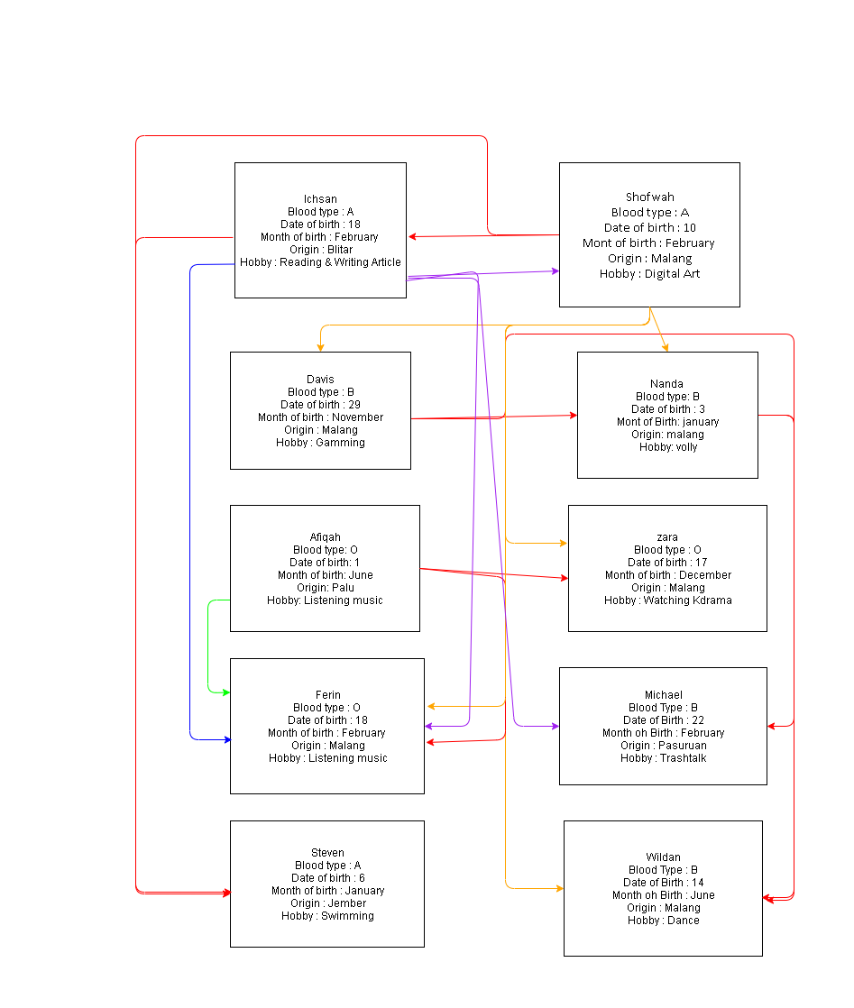
- Nanda, Davis, Michael, Wildan
- No one, because my month birth is August.
- No one, because my birth date is 24.
- No one, because I from Surabaya.
- Ichsan and Steven, because my hobby is reading and swimming.
- Input :price every 1kg Rp4.500, ani 4kg, budi 15kg, bina 2kg, cita 11kg.
Process :
- First, search known data.
- Then calculate for all customers.
- Ani = 4 * 4.500 = Rp18.000
- Budi = 15 * 4.500 = Rp67.500 * 5 % = 67.500 – 3.375 = Rp64.125
- Bina = 2 * 4.500 = Rp9.000
- Cita = 11 * 4.500 = Rp49.500 * 5 % = 49.500 - 2.475 = Rp47.025
- Total = 18.000 + 64.125 + 9.000 + 47.025 = Rp138.150
Output : Total income

